**Deploy Container with Node.js application**

**Process:**

**Set Up AWS Resources**

Logged in to AWS Management Console.  
• Launched EC2 Instance: (virtual machine - Ubuntu).

And security groups to allowed HTTP (port 80),HTTPS and SSH (port 22) traffic with instance type - T2.medium and 15Gb disk size and created PPK file.

**Connect to Your EC2 Instance**

•    Used SSH to connect to EC2 instance using the PPK file via Putty as below

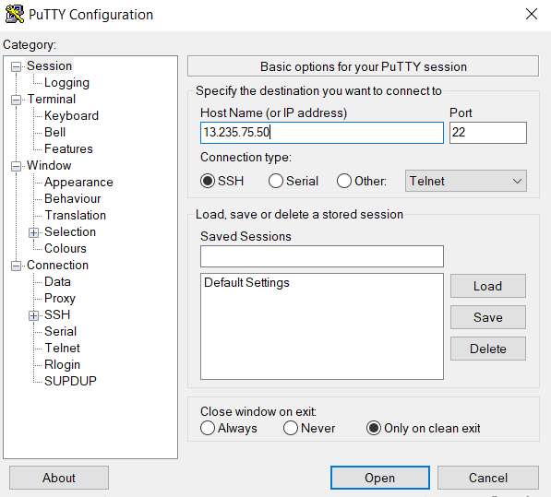

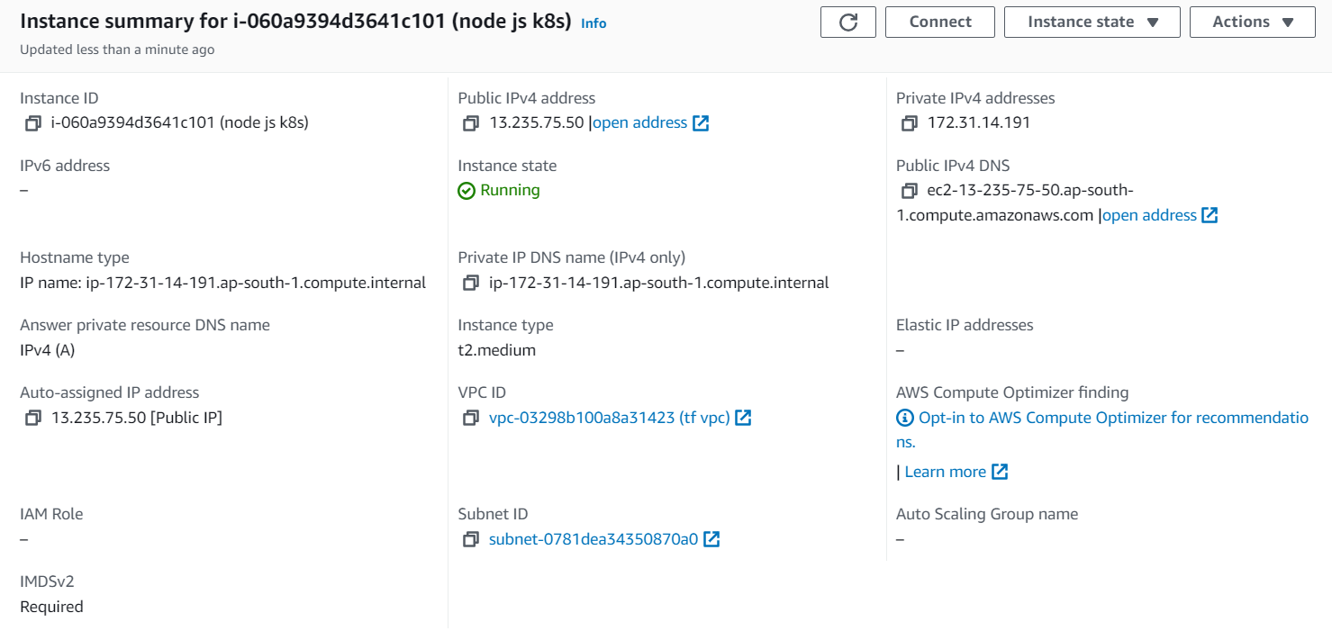

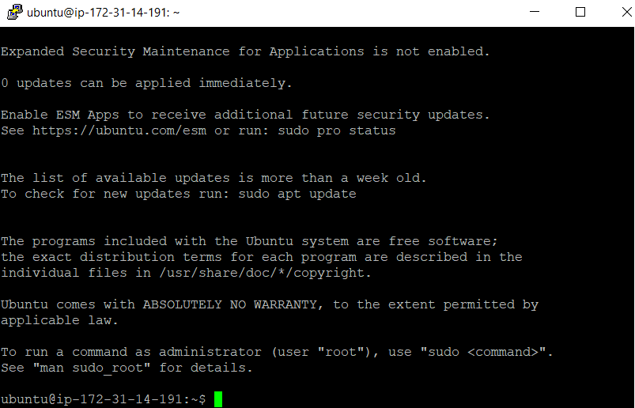

**Attached IAM role to the machine.**

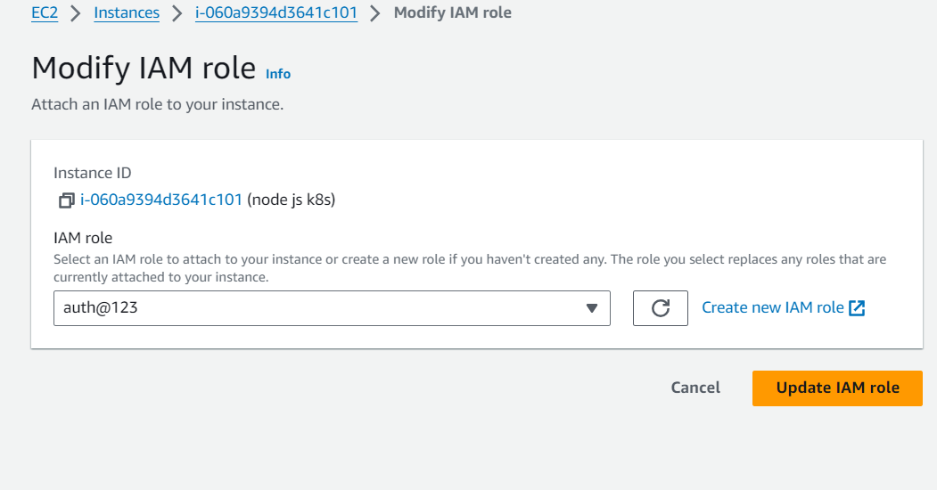

**Prerequisites:**

**Installed docker on to the machine.**

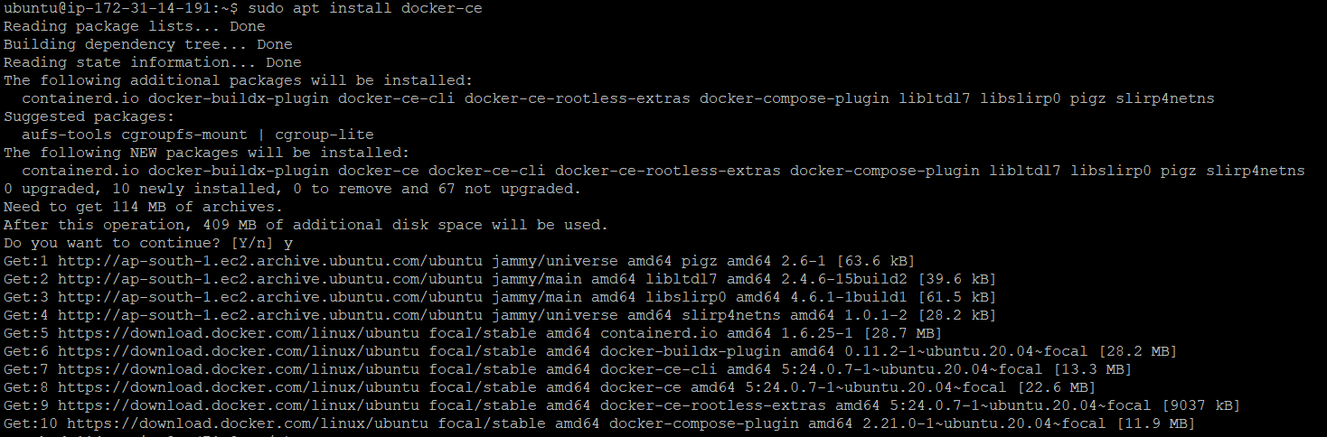

**Cloned the Nodejs code from git repository**

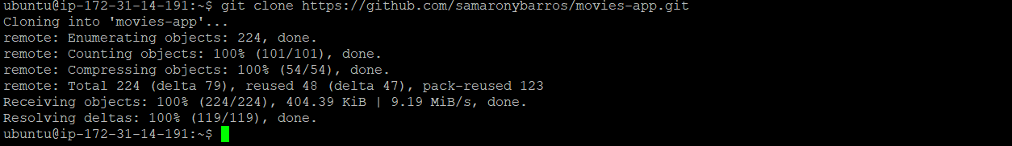

**Changed directory to the code path as below:**

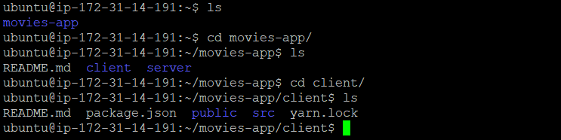

**Installed Nodejs and npm on to the machine.**

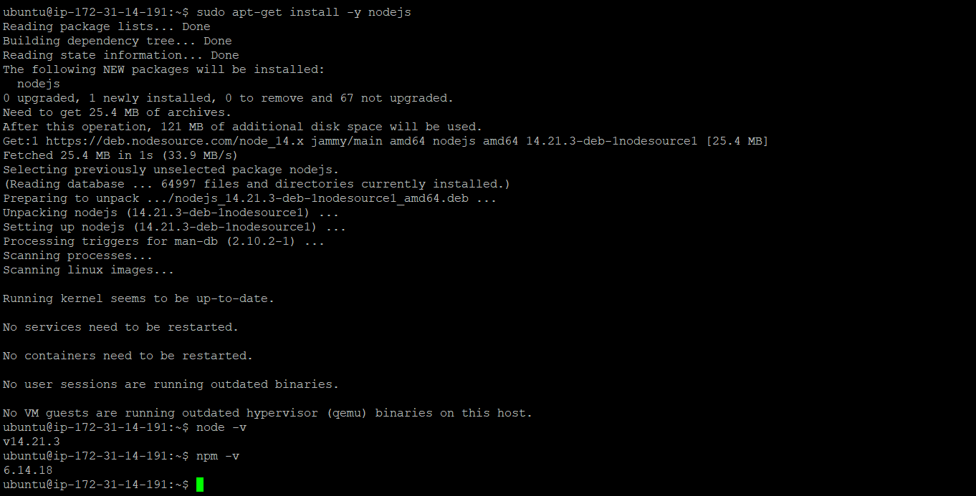

**Dockerize the Application:**

**Created a Dockerfile:**

FROM node:14

WORKDIR /home/ubuntu/movies-app/client

COPY package*.json ./

RUN npm install

COPY . .

EXPOSE 3000

CMD ["node", "index.js"]

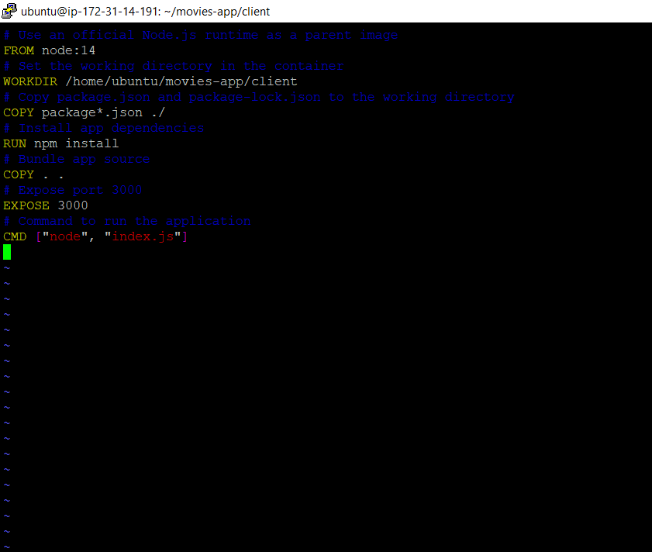

**After created a image we built up it by using docker build command:**

* Sudo docker build -t ksnode:latest

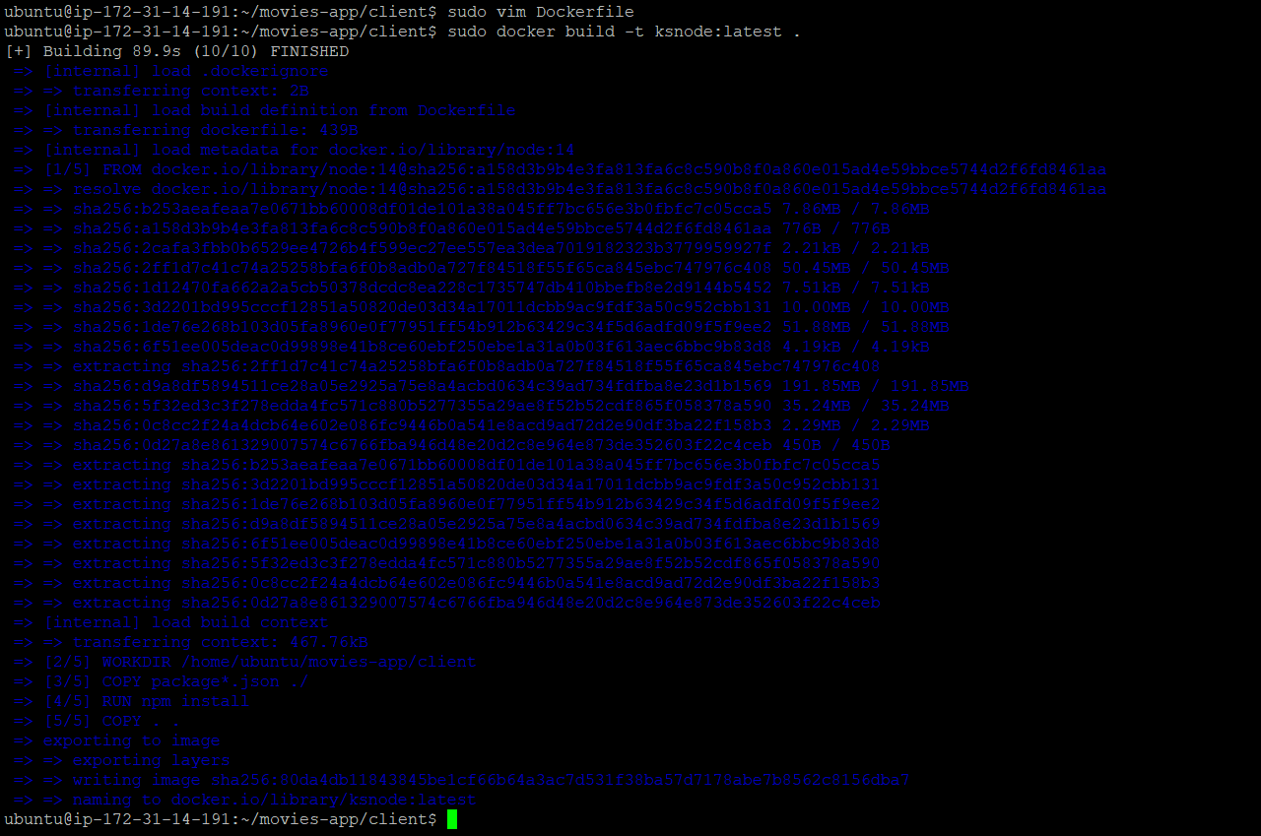

**As we can see docker image below created from building docker file.**



**Added port 3000 entry to the SG.**

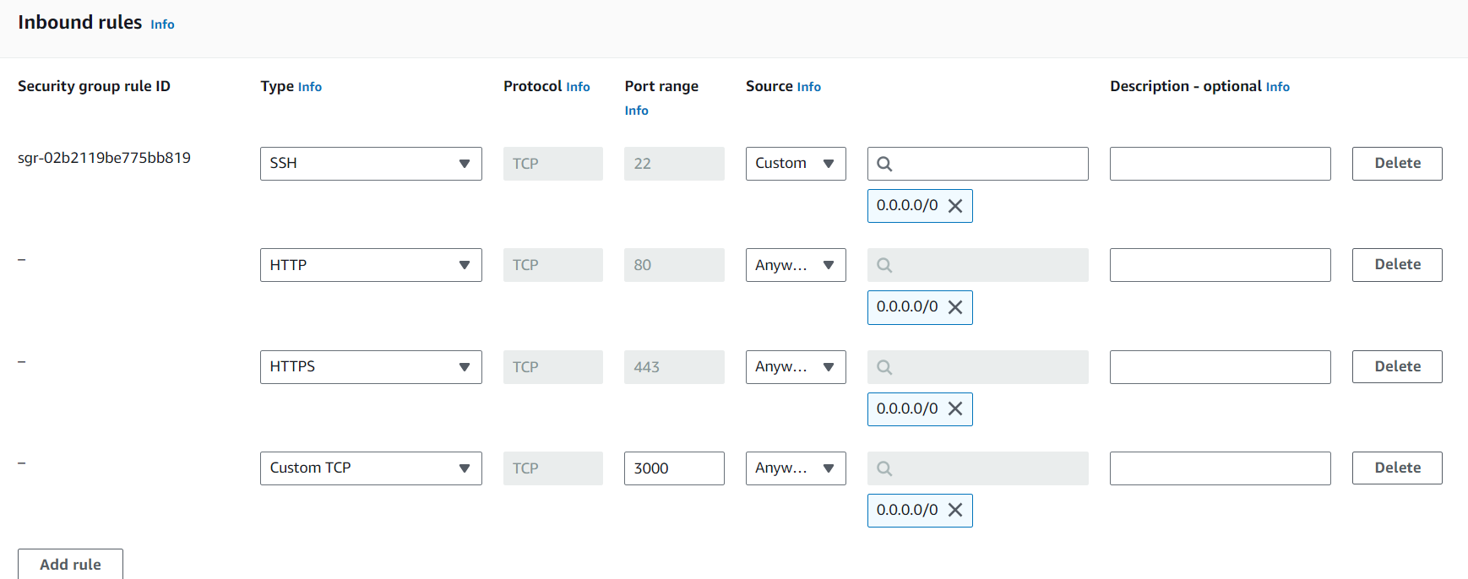

**Installed python on the machine .**

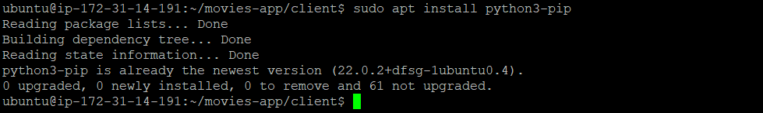

**Installed AWS Cli on to the machine.**

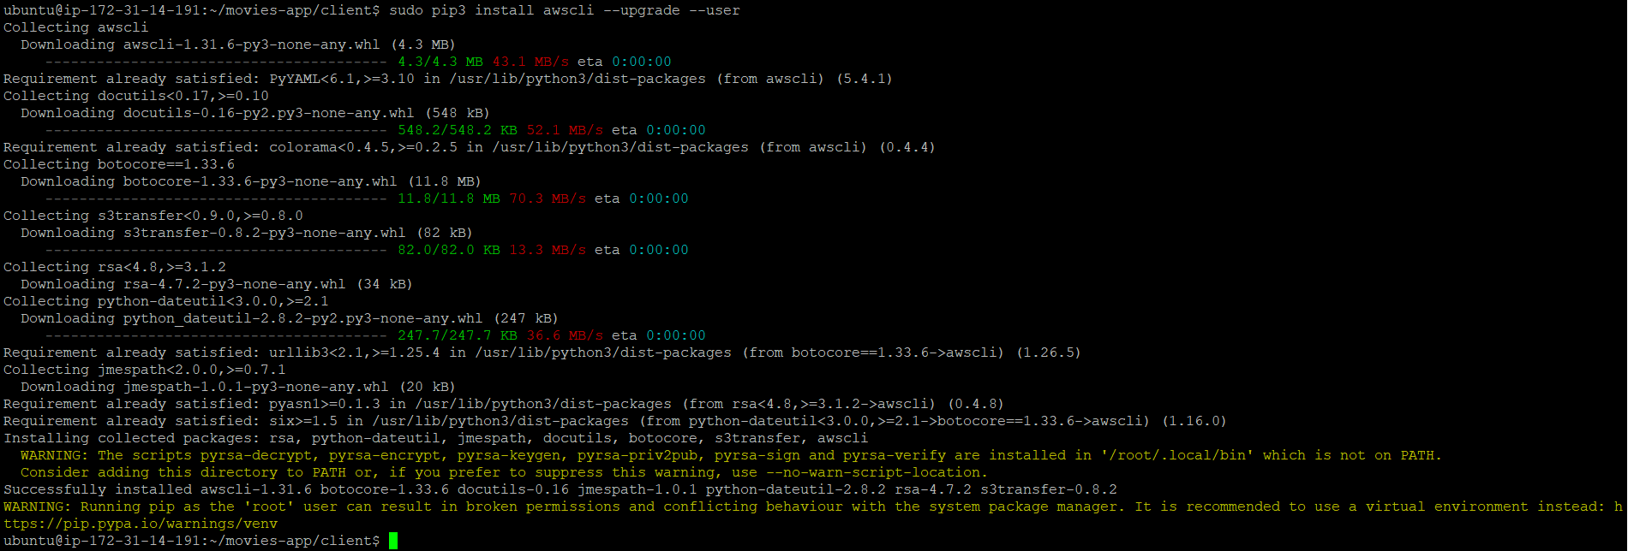

**Installed Kubectl on to the machine:**



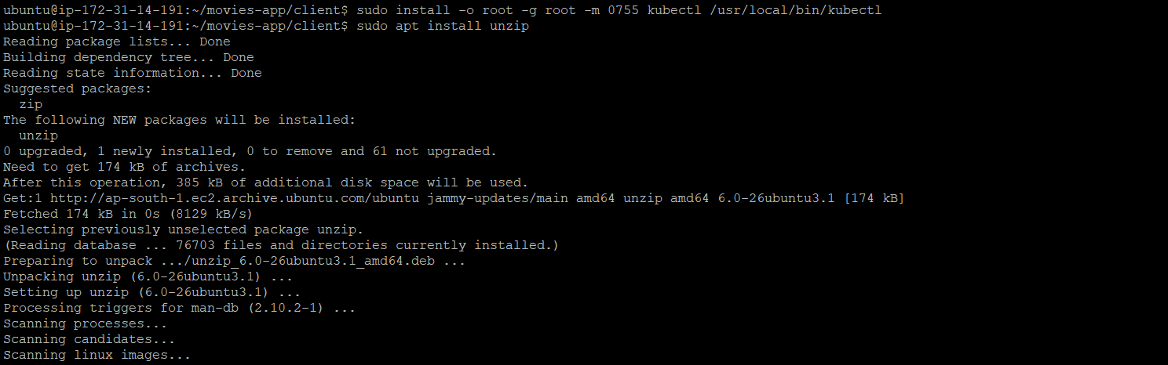

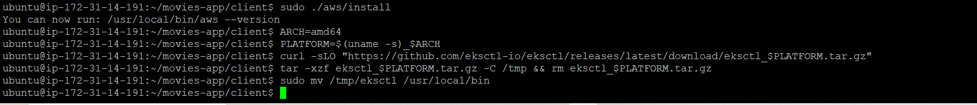



**deployment.yaml**

apiVersion: apps/v1

kind: Deployment

metadata:

name: movies-app

spec:

replicas: 3

selector:

matchLabels:

app: movies-app

template:

metadata:

labels:

app: movie-app

spec:

containers:

- name: movies-app

image: ksnode:latest

ports:

- containerPort: 3000

resources:

requests:

memory: "64Mi"

cpu: "250m"

limits:

memory: "128Mi"

cpu: "500m"

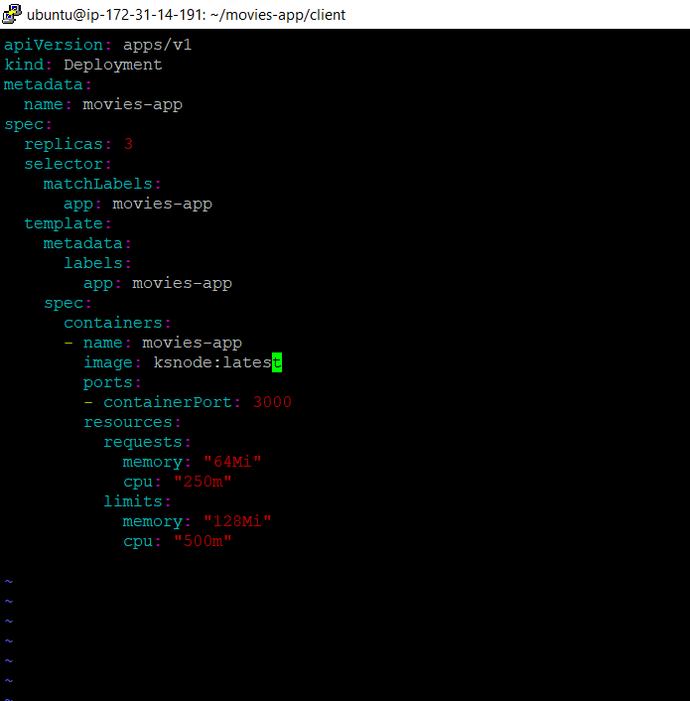

**Created a cluster as below :**

**Cluster name : kokan**

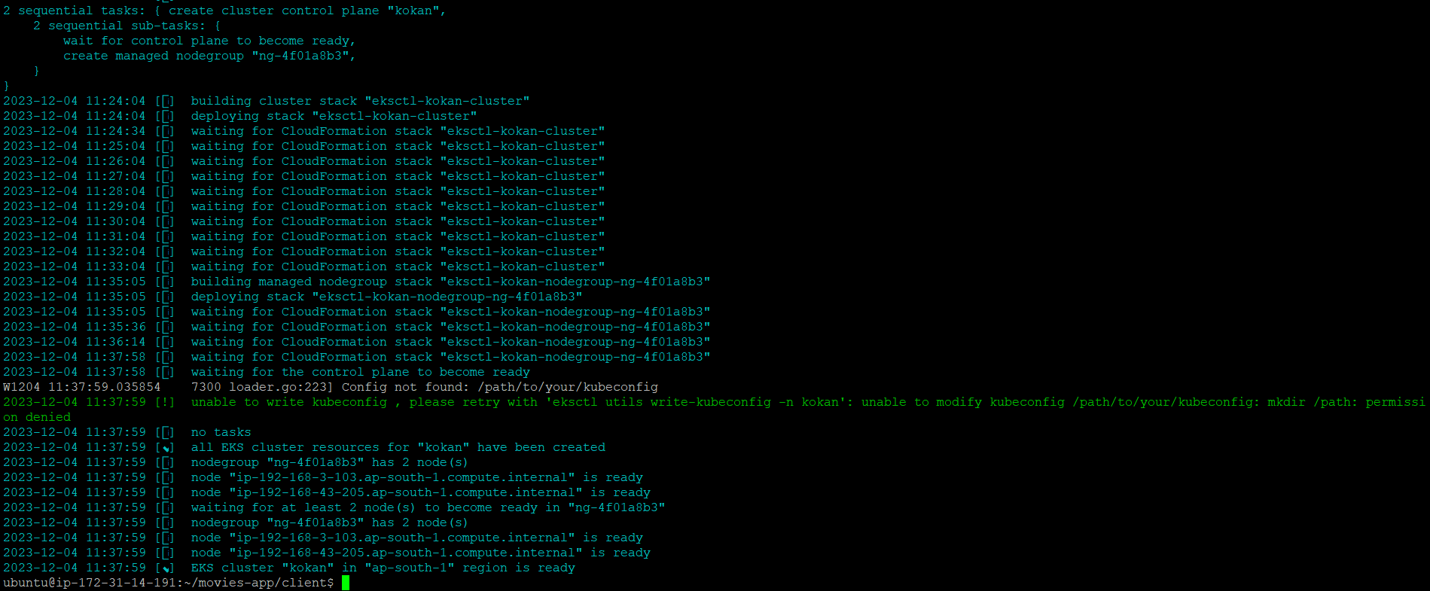

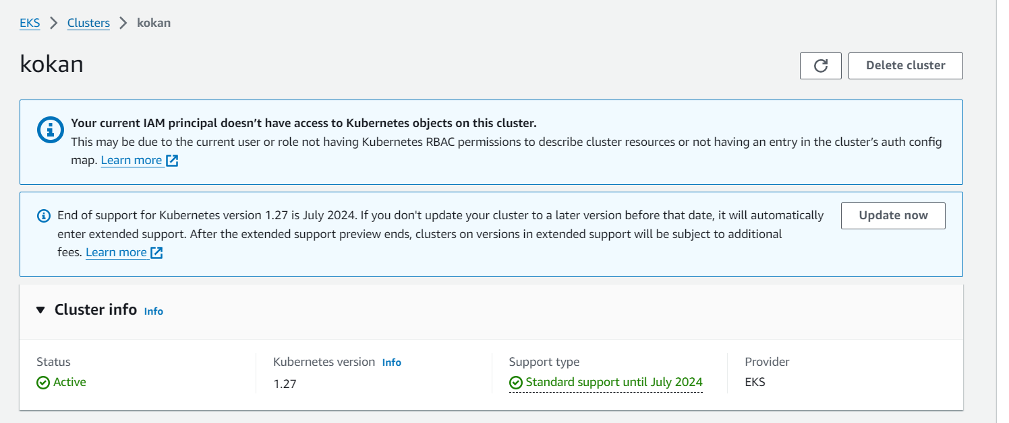

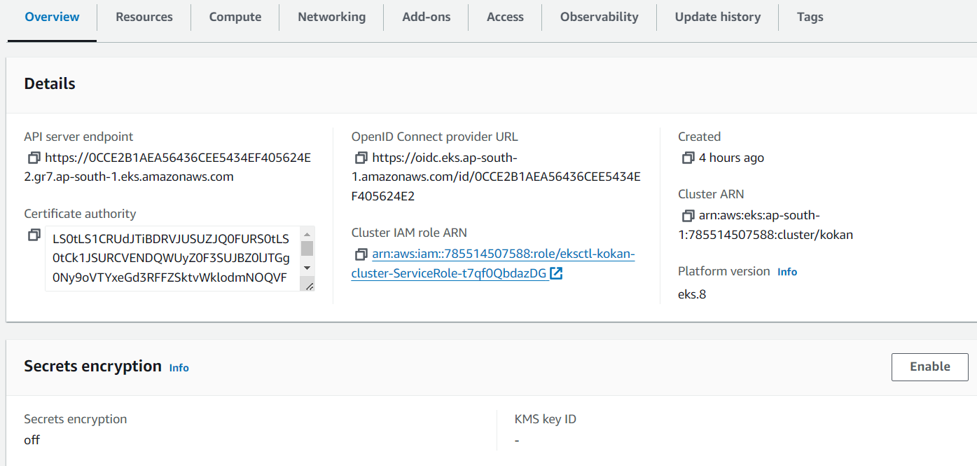



**And deployed deployment.yaml on to the cluster using below command:**

* sudo kubectl apply -f deployment.yaml



**Now for accessing a application we need service.yaml**

**Service.yaml**

apiVersion: v1

kind: Service

metadata:

name: service-app

spec:

selector:

app: movies-app

ports:

- protocol: TCP

port: 80

targetPort: 3000

type: LoadBalancer

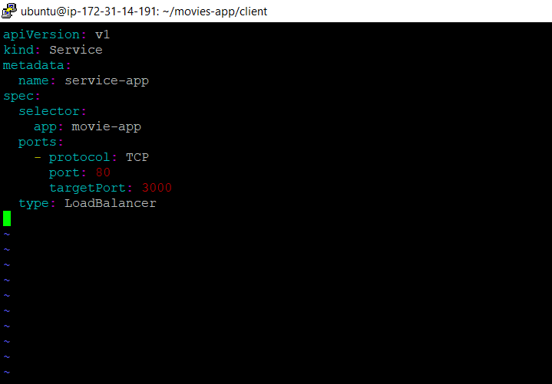

**Apply and deployed a service file on to the cluster using below command:**



**And finally we got the external ip to access a application on browser.**



URL : <http://a4ca654a8552545d29f0b798ab787089-31233558.ap-south-1.elb.amazonaws.com/>

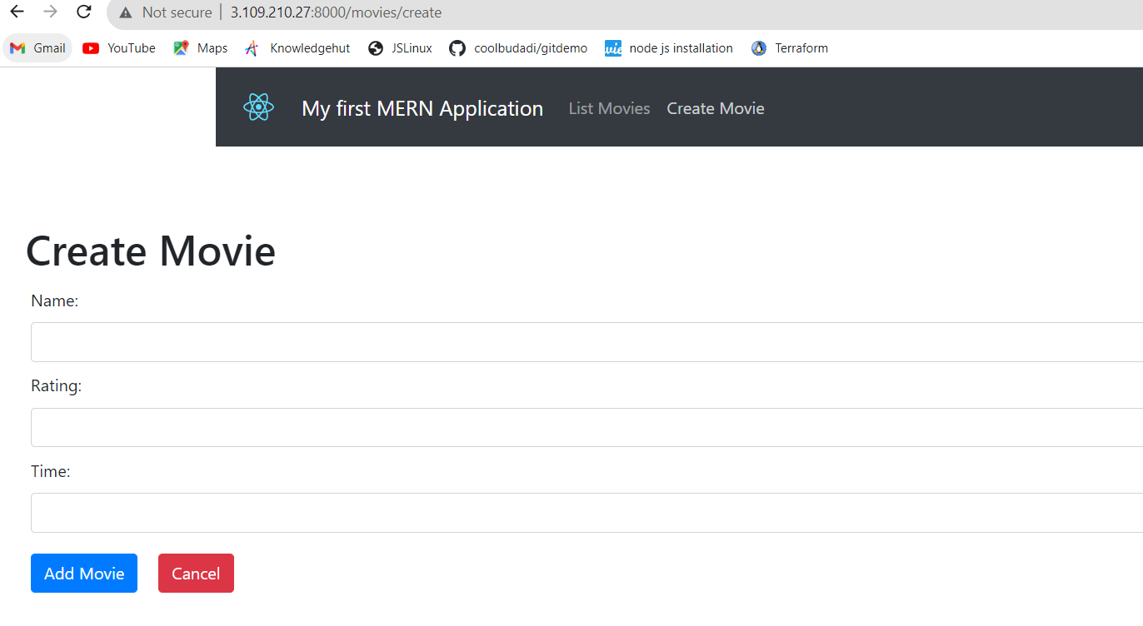

Git Repo : <https://github.com/samaronybarros/movies-app.git>